TASK - 1
1. IoT and its applications :
#what is IoT?
IoT is essentially a platform where embedded devices are connected to the internet, so they can collect and exchange data with each other. It enables devices to interact, collaborate and, learn from each other’s experiences just like humans do.
#How IoT works?
An IoT ecosystem consists of web-enabled smart devices that use embedded systems, such as processors, sensors and communication hardware, to collect, send and act on data they acquire from their environments. IoT devices share the sensor data they collect by connecting to an IoT gateway or other edge device where data is either sent to the cloud to be analyzed or analyzed locally. Sometimes, these devices communicate with other related devices and act on the information they get from one another. The devices do most of the work without human intervention, although people can interact with the devices -- for instance, to set them up, give them instructions or access the data.
to understand easily watch - https://youtu.be/LlhmzVL5bm8
#Some IoT applications :
(know about applications through given link)
Wearables - https://www.edureka.co/blog/iot-applications/#wearables
Smart Home Applications - https://www.edureka.co/blog/iot-applications/#smart%20home%20applications
Health Care - https://www.edureka.co/blog/iot-applications/#healthcare
Smart Cities - https://www.edureka.co/blog/iot-applications/#smart%20cities
Agriculture - https://www.edureka.co/blog/iot-applications/#agriculture
Industrial Automation - https://www.edureka.co/blog/iot-applications/#industrial%20automation
2. NodeMCU :
NodeMCU is a low-cost open source IoT platform. It initially included firmware which runs on the ESP8266 Wi-Fi SoC from Espressif Systems, and hardware which was based on the ESP-12 module. Later, support for the ESP32 32-bit MCU was added. ESP8266 is a low-cost, WiFi Module chip that can be configured to connect to the Internet for Internet of Things (IoT) and similar Technology Projects.
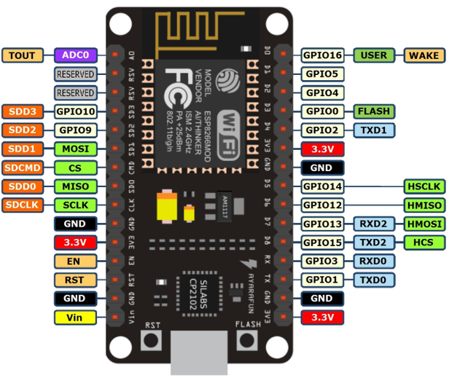
pin configuration :

for more information - https://components101.com/wireless/esp8266-pinout-configuration-features-datasheet
3. Arduino :
Arduino is an open-source prototyping platform used for building electronics projects. It consists of both a physical programmable circuit board and a software, or IDE (Integrated Development Environment) that runs on your computer, where you can write and upload the computer code to the physical board.
for more information - https://www.arduino.cc/en/guide/introduction
4. Difference between NodeMCU and Arduino :
NodeMCU | Arduino UNO
128KB RAM | 2kB RAM
4MBytes ROM(flash) | 32 KB ROM
micro USB port | USB type B connector
Small Board Size | Bigger in size than NodeMCU
Inbuild wifi module | to be add externaly
For more information watch - https://youtu.be/IOA3tIa743E
5. WiFi Module (ESP8266) :
ESP8266 is Wi-Fi enabled system on chip (SoC) module developed by Espressif system. It is mostly used for development of IoT (Internet of Things) embedded applications.
ESP8266 comes with capabilities of :
*2.4 GHz Wi-Fi (802.11 b/g/n, supporting WPA/WPA2),
*general-purpose input/output (16 GPIO),
*Inter-Integrated Circuit (I²C) serial communication protocol,
*analog-to-digital conversion (10-bit ADC)
*Serial Peripheral Interface (SPI) serial communication protocol,
*I²S (Inter-IC Sound) interfaces with DMA(Direct Memory Access) (sharing pins with GPIO),
*UART (on dedicated pins, plus a transmit-only UART can be enabled on GPIO2), and
*pulse-width modulation (PWM).
for more information - https://www.electronicwings.com/sensors-modules/esp8266-wifi-module
Bibliography :
https://youtu.be/IOA3tIa743E
https://youtu.be/OfGxbxUCa2k
https://youtu.be/LlhmzVL5bm8
https://www.electronicwings.com/nodemcu/introduction-to-nodemcu
https://www.edureka.co/blog/iot-applications/#wearables

